Final DocumentationVisCanvas Data Visualization SoftwareProvided by:
Daniel Ortyn
Nicolas Espitia
Shane Vance
Brennan Barni
Data Visualization Group A
2-28-2018

Table of Contents
Problem Statement 3
Requirements 3
External Interface Requirements 3
User Interfaces 3
Hardware Requirements 3
Software Interfaces 3
System Features 3
Back-End Data Structures and Algorithms 3
VisCanvas Graphical User Interface 4
VisCanvas Visualization View Window 4
Additional Nonfunctional Requirements 5
Performance Requirements 5
Safety/Security Requirements 5
Software Quality Attributes 5
Design 6
High Level 6
Low Level 7
Test Cases 8
Case One – Basic Comma Delimited Text file Read-in Function 8
Case Two – Saving and Loading Custom File Functions 8
Case Three – Client Software Testing 9
Case Four – Data Properties Manipulation 9
Case Five – Mouse Input 10

Problem Statement
The requested software from out client was to create a proprietary software to visualize and analyze multidimensional data from a comma, delimited text file. The software should be capable of multiple instances of hypercubes in respect to a specified n-dimensional coordinate; panning and zooming to navigate the display window; save progress to an output comma delimited text file to resume progress from a previous session with the software. The client heavily emphasizes a user-friendly interface, as the previous iteration of this project was lacking reasonable accessibility. The team is creating the software under callsign VisCanvas.

Requirements

External Interface Requirements

User Interfaces
Client specified that the UI must be easy to understand with as little explanation as possible in order to use the functions of the software. The main window will connect the user to many of the specified functions requested by the client. These functions will be represented by buttons on the left side panel on the main window. Requirements concerning properties of the data (i.e. color; class/set names; data values) will be accessible through the right panel of the window. There will also be a secondary window that can be opened to access more data properties and preferences.
Users who are familiar with popular word processors will be immediately familiar with the options presented to them by the VisCanvas user interface. In addition, they will be able to access comprehensive help documentation through the “help” option in the menu bar at the top of the screen.

Hardware Requirements
The software should be capable of being run offline on systems running Windows operating systems as old as Windows 7. Input taken from any I/O devices will be from a keyboard and mouse. All functions will be able to be accessed through just the mouse if necessary. The memory requirements to achieve the necessary objectives are minor when compared to most contemporary word processors or image editing software. The software should theoretically be able to be accessed by any hardware that has access to C++ and OpenGL.

Software Interfaces
Aside from the OpenGL Graphical Framework, VisCanvas will not rely on any other plugins, software, or libraries. Everything used in the development of the product will be available via the standard C++ library and/or OpenGL. This was explicitly done to ensure portability, as well as prevent the software from being muddled down by unnecessary libraries or interfaces.

System Features

Back-End Data Structures and Algorithms
The underlying data structures, algorithms, and functions will parse, process, and prepare the data to be sent to the VisCanvas viewing window.
The only user input necessary in the operation of the back-end of this software will be the data files themselves. Other than that, the software will automate the process of producing a visualization from user input data. However, if the data contains characters, numbers, symbols, etc. that aren't intended for the parsing algorithm, the user will be informed that their input is invalid and instructed on how to prepare a data file for the purposes of visualization via VisCanvas.
The functional requirements are as follows:
- Data parsing algorithm
- User input function
- Functions to pass information to other parts of the software
- Extensive testing and try/catch but hunting to ensure a stable product
- File Browser

VisCanvas Graphical User Interface
Provides the user with an immediately familiar and highly usable interface through which they can interact with and modify the data visualization. A very early prototype of the GUI will need to be implemented to develop the VisCanvas view window, however, so it will take slightly higher precedence in the early stages of development.
Users who are familiar with popular word processors will be immediately familiar with the options presented to them by the VisCanvas user interface. They will be able to load and save files, access all the tools provided by the software nad ideally be able to load data from previous visualizations used by the software. In addition, they will be able to access comprehensive help documentation through the “help” option in the menu bar at the top of the screen.
The requirements are as follows:
- File/Edit/View/Tools/Winodw/Help top-of-screen menu
- File browser window to choose data files to load from and save to
- Toolbar
- Data properties (panel on right side of window and through secondary properties window panel)
- Click & Drag functionality for dropping data into the software to be visualized

VisCanvas Visualization View Window
The VisCanvas Visualization View Window will be the method by which the software delivers its interactive data visualizations to the user, and also the environment within which the user will modify data points from the visualization. Users will be able to click and drag data points in order to transform the visualization in real time.
The requirements are as follows:
- Functions to transform data points into screen coordinates, then draw lines between coordinates in real time (redrawing them as they are manipulated by the user)
- User input function to add new points and draw lines to and from them
- Functions to pass information to other parts of the software
- Extensive testing and try/catch bug hunting to ensure a stable product

Additional Nonfunctional Requirements

Performance Requirements
Despite any user input, the software should run at a smooth rate with no hitches in performance. Due to the relatively simplistic nature of the visualization software (from the perspective of efficient memory access), this requirement will not be difficult to meet. However, it demands that we handle memory access within C++ effectively, use the fastest possible sorting, parsing, and rendering algorithms, and maintain vigilance over potential memory leaks or other possible hits against the software's performance.

Safety/Security Requirements
Because VisCanvas does not access any information other than what the user chooses to provide, security will not be a likely issue. However, if production of VisCanvas is to continue, Visualization Team A will need to keep potential security risks in the forefront of their design philosophy whenever adding new, potentially more invasive, functions in the future. The only real safety concern is ensuring that the data files are not altered when access to retrieve the data. Otherwise the program has no access to sensitive files and does not generate any sensitive files so security is not a concern and neither is safety.

Software Quality Attributes
VisCanvas will be continually tested with various potential users in order to identify and categorize bugs, missing features, inefficient UI, or other potential road bumps in the production of the software. The primary quality characteristics that will be championed by Visualization Team A in the development of VisCanvas will be: robustness, usability. The software must be as ordered by Dr. Boris Kovalerchuk, but also must be robust easily testable for future development. Portability and usability will ensure that any of Dr. Kovalerchuk's students can make the best possible use of the software in their research of data visualizations. Because the intended users for VisCanvas are students and faculty of computer science, we will emphasize ease of use over ease of learning.

Design

High Level
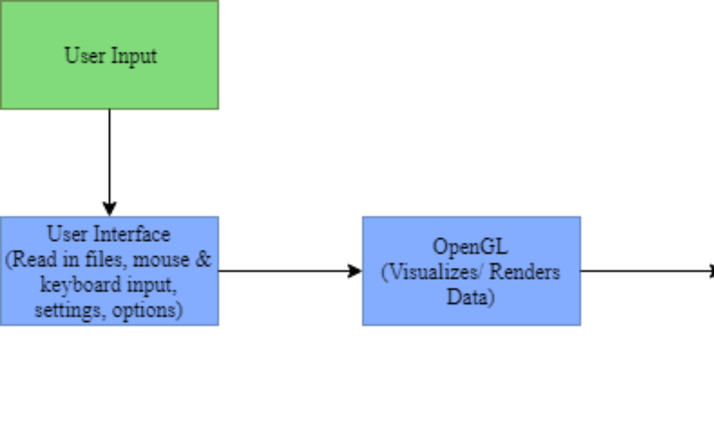
Figure 1 High Level Design of VisCanvas
Many of the functions of the software is dependent on the existence of read in data from a comma delimited file. With that said, a text file loaded by the user is the first most important input needed by the program. Once the program successfully reads the data from the file, the OpenGL class will visualize and render the data, along with saving the values of the plotted points into the Data Interface class. From here the user can continue input through mouse clicks and keyboard presses that will use the functions linked from the user interface to affect the visualization and data values until the user is satisfied with the visualized data. Once satisfied with the analysis and manipulations performed, the user can save the visualization into the form of the readable comma delimited file (which can be re-read into the software during a later session).

Low Level
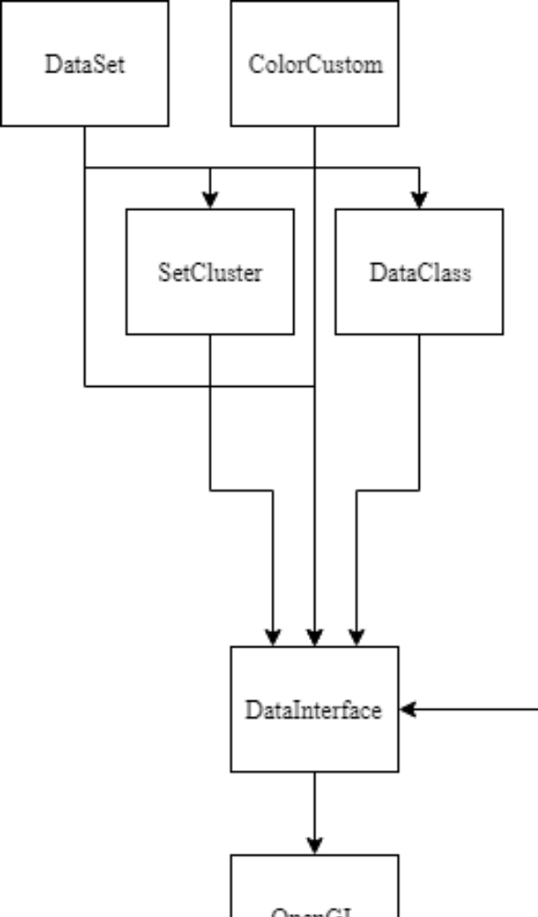
Figure 2 Low-Level Design of the classes created for the software
The final software consists of nine classes for the necessary data and functions appropriately organized for proper information access and modularity. The data read in will be placed into the dimensions, sets, and classes. Dimensions hold individual values of data where n-dimensions consist of one coordinate. Each set consists of n-dimensions, determined by the number of elements on each line of the text file. There can only be the same number of dimensions across each set. Classes consist of m number of sets. The software is designed to account for up to five classes at a time. Each set is assigned a class, determined by the last element of each line. If the user wishes to assign a set to a different class, they may change that field in the properties window.
Information from the “DataInterface” class is retrieved by the “OpenGL” class and rendered to the screen of the VisCanvas main window. Any input sent from the user on the main window will be received by the VisCanvas through the appropriate input listeners. Manipulations will be calculated in the “OpenGL” class and well as the necessary renders. The “DataInterface” class is not affected by any changes to preserve the integrity of the original data. This is intended to allow the software to properly revert any changes that they may have performed with the data manipulation and analysis functions.

Test Cases

Case One – Basic Comma Delimited Text file Read-in Function
Description: The requirements specified between the client and the team specified that data will only be read in from comma delimited text files. To make sure the software can deal with faulty text files, the program performed through various text files will minor differences in format and errors. This ranged from instances such as spaces along with commas, commas with no data between them, and files with a greater amount of data than specified by the client.
Outcome: Performance for this scenario turned out promising. The program can successfully read in and graph data from properly comma delimited text files with no issue. When it came to text files that included spaces along with the commas, the software would not be able to read in the data. However, the necessary provisions were made to cause a “soft” error, allowing the program to continue running afterwards awaiting further instructions. It was requested by the client to be able to have options to toggle the first columns and rows of a file to be read in as dimensional fields and names of the sets respectively. This contrasts with the existing function as considering the first columns and rows to be read in as data dimensions and sets respectively.

Case Two – Saving and Loading Custom File Functions
Description: Ability to save load progress of a visualization created from a previous session was one of the first requirements discussed during the first phases of consultation. The plan is to create changes to the same data text file with multiple saves, each consisting of different changes performed to the data. This can include: different color values to the data and backgrounds; different degrees in vertical dimensional shifting; manual sorting of dimensions; sorting lines along different sets of data; etc. Each instance of a visualization with the same original data was created in their own software session. After loading a visualization save file to check for one to one accuracy, the software will be closed and reopened to load for the other save file cases.
Outcome: There were a total of five test cases, with all different degrees of changes performed with no visualizations appearing the same. All results were the same for call cases: all visualizations were maintained except for the background color. This was an intentional decision as the team deemed the background color to be of very low priority. The consensus was that the user can change the field on the fly upon the reloading of save files. During client testing however, it was requested to have the background color to be a saved feature in the data file format. The necessary changes can be easily implemented and are expected to be complete within the next few days.

Case Three – Client Software Testing
Description: While the team and client share a mutual satisfaction with the layout of the main window and secondary window, the software now must be tested to see if the average end user can navigate all the necessary functions with as little outside assistance as possible. The team tested with students from the computer science department. Tester selection emphasized selection from students familiar with CS 445 as they are familiar with principles regarding hypercubes. This criterion however did not make final decisions among students however, as students who still did not take CS 445 were still chosen. It should be noted that the primary user of this program is our client. Outside users are not specified
Outcome: On the 27th of February, we had shown our software to our client/supervisor the project. While we were able to fulfill many of the requirements requested by our client, we had our share of issues and bugs become visible once our client got their hands on the program.
The data files that were read in were reading the first columns to be the names of each set. In the client’s data, the first data was the first dimension of data for every coordinate. Ability to toggle the first column and row to be read in as names of fields or data is requested by our client.
Testing showed that navigation of the user interface was more of a feat than we wanted it to be. To start, while we did have the zoom feature in the build, the function was too discrete to effectively find for our client’s first run at the software. There is also an evident issue with highlighting a set of data. In order, to highlight a set of data, the only way to do so is to navigate with the ‘up’ and ‘down’ or ‘w’ and ‘s’ keys. Consequently, if the user wants to reach data in the middle of the text file, they would have to continuously press the keys until the desired set of data has been reached. Client kept attempting to access the data properties by looking for the properties at the top left. Unfortunately, to reach the properties, the link was located at the bottom right. This can either be remedied through either placing the button at one of the menus at the top left of the screen or making the button at the bottom left much more visible. Labeling of some fields and buttons are also necessary as some functions and fields were not very clear or it was misleading during testing.
Regarding functionality, many of the requirements requested by the user was fulfilled with little friction. While accessing functions may have been less clear than desired, they performed just as the client desired.

Case Four – Data Properties Manipulation
Description: The software provides a secondary window to view and manipulate properties of multiple data groups: class, set, dimension, and cluster. The design of the software is intended to not make any permanent changes to the data as the user may want to revert changes later. The group wants to the manipulation functions for proper functionality, integrity of original data, and general debugging purposes. Multiple sessions will be run on the same data, each session dedicated to manipulating a data group represented in the properties window.
Outcome: Results from testing turned out favorable for each of the properties and fields tested. This is for sure credited to the structure of the classes and the methods created for proper accessing of necessary fields. Proper data modifiers are performed upon data while maintaining the integrity of the original data values for necessary reverting.
Case Five – Mouse Input
Description: Aside from typical navigation, the mouse is also required for graph for manual dimension sorting and vertical shifting. The top first toggle buttons at the top of the left panel are used to enable the mentioned functionality. Testing for these functions are straightforward: ensure proper functionality through proper rendering in real time, handling of passive mouse dragging, and being able to save changes to a save file.
Outcome: Testing results were gathered at the same time as case three, and fortunately showed many of the functions satisfied the client’s requirements. The mouse coordinates were able to be accurately taken into the functions necessary to provide positive visual behavior when clicking on and near the targeted dimension. Any passive mouse dragging was correctly scaled to drag dimensions horizontally and vertically across the screen at a one to one scale of the graphing window. Changes were also successfully saved and loaded in separate sessions with the software. One issue that needs to be remedied is being able to perform manual sorting and vertical shifting when the camera is zoomed in anywhere on the graph. The projection of the graphed data when zoomed in does not permit the mentioned manipulation functions do not consider the screen height or width appropriately outside of the default view. Actions will be taken to solve the issue, but this is not considered a priority for the final product deadline and may be dropped.
Case Six – Dimension Swapping
Description: When using the mouse to drag and drop dimensions, swapping them with one another horizontally, if the user moves the mouse erratically or too quickly, the dimensions can end up getting randomly “scrambled,” resulting in an unreadable mess of data. The situations that cause this outcome must be tested and, if possible, fixed before release.
Outcome: Testing results were gathered shortly after integration of dimension swapping. Due to how the dimension swapping is handled in our data structure, and how VisCanvas draws from said data structure, there was unfortunately very little we could change that would prevent a user from intentionally recreating this error. Changes were made to the click and drag function in order to ensure that the only situation that would cause this error would be if the user was intentionally casting the mouse cursor across the screen as fast as possible, so to minimize the impact of this unintentional quirk of our design. Potential further fixes were proposed by multiple group members, but all involved changing fundamental elements of our software's design, and therefore would take too long to be successfully administered before the final deadline of our release version. Although our changes to the click and drag functionality to prevent this issue from becoming detrimental to the proper function have been effective, if given more time we would have liked to fix this issue in its entirety.
Case Seven – File Size Stress Testing
Description: Although the client only required the software to handle 15 sets of up to 20 dimensional data, we desired to create a software that could easily handle even larger and more complex data sets. As such, from the start we were optimizing our software to handle massive amounts of data.
Outcome: Testing was done throughout development of our software, but most of the vital testing results were gathered shortly after implementing our data structures and data drawing functions. We tested the software with 100 sets of 1000 dimensional data: a dataset so large that nobody outside of an artificial intelligence would be able to analyze it in parallel coordinates all at once. The results were phenomenal; the software handled the massive data file without a single hitch in performance or draw time. Through this larger-than-useful data file testing, we have confirmed that our software will easily handle any sets of data the user desires. This data, when visualized, was of course entirely unreadable due to the density of data points; perhaps in potential future development of the software, a highly advanced zoom function to interpret such highly dense datasets might be considered.
Case Eight – Panning “Squishing” Dimensions
Description: Upon initial implementation of our dimension panning, we quickly discovered that panning the camera up and down would cause our dimensions to “shorten,” decreasing in height, as we moved the dimensions up the Y axis. They would lengthen back to their original settings upon being dragged back down.
Outcome: Testing was performed over the course of a few days following the discovery of this error. For awhile, we could not isolate what was causing this error, however we eventually discovered through constant testing and tweaking of our panning method that the worldWidth and worldHeight values being passed to the function setting the orthosphere of the visualization were inverted. Once this was discovered, it was a quick fix to swap the worldWidth and worldHeight to their proper order, fixing the error in its entirety.

